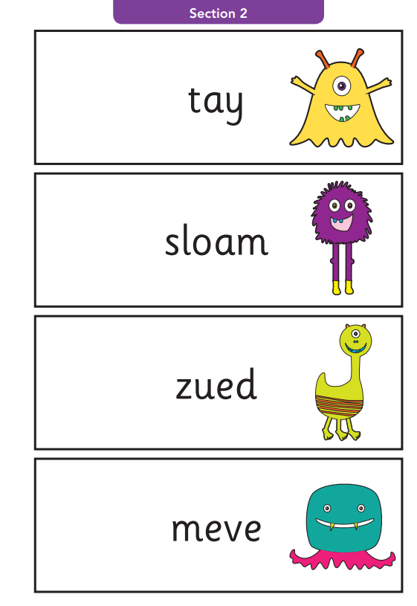
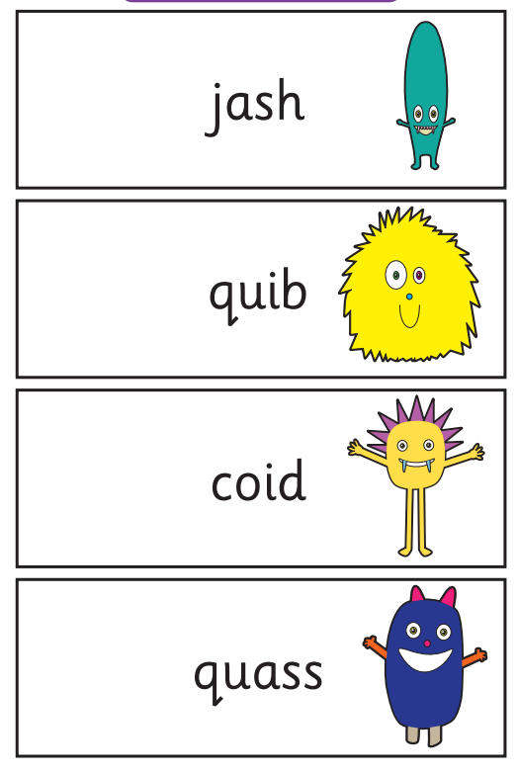
These are a selection of ‘alien words’ that are used in the Phonics Screening check. The children will need to use their phonic knowledge to decode these words in order to read them.

