Tuesday 13th September 2021

Allergies

Dear Parents and Carers,

As many of you will be aware, we have a number of children in our school with food allergies. Nut allergies are particularly common. For many children, the symptoms are mild. For others the reaction can be more severe resulting in collapse or unconsciousness; it is a life-threatening condition, although this is rare.

As a school we have a duty of care to all pupils, and we are therefore asking all families, at the start of the new year, to be mindful of sending food into school that may contain nuts; this may be as a snack, lunch or treats for the classes. Often nuts or nut based products are contained in food that you wouldn’t necessarily think about such as chocolate spreads / treats as well in baked goods and lots of vegetarian foods.

If you would like further information please visit http://www.allergyuk.org or http://www.anaphylaxis.org.uk/ .

Thank you for your support and understanding with this matter.

Yours sincerely
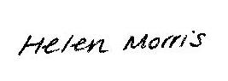
Headteacher

